**Protocol for running 7 tesla MRI scanner**

**Abstract**

This protocol provides a step-by-step instruction on how to get Cine

1. **Get the location of the heart**

**How to start:**

1. Turn the power gauge to ON.

1. Press standby and let it to turn into solid orange/yellow light
2. Then press ON button and wait until it turns into solid green.
3. Open “ParaVision 360” software from the desktop of “Bruker” computer.

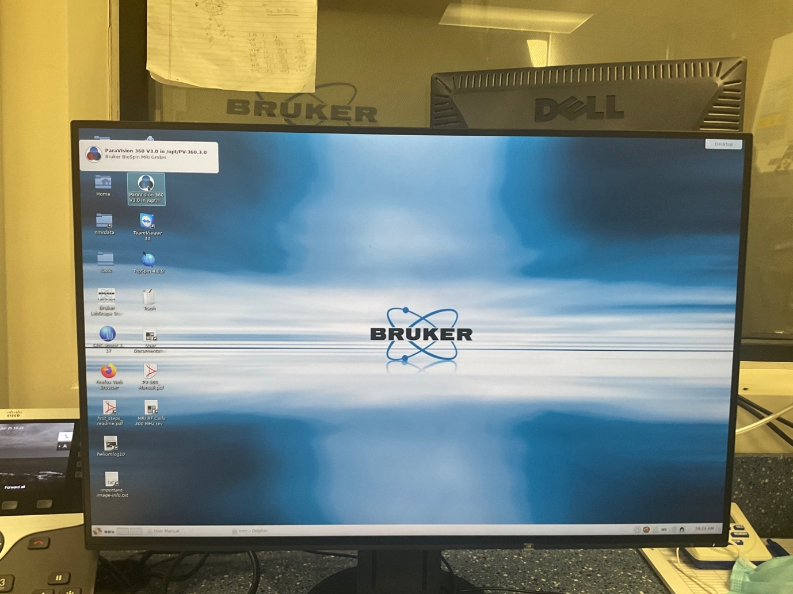

1. Allow the software to load up and DO NOT close any of the windows that automatically opens.

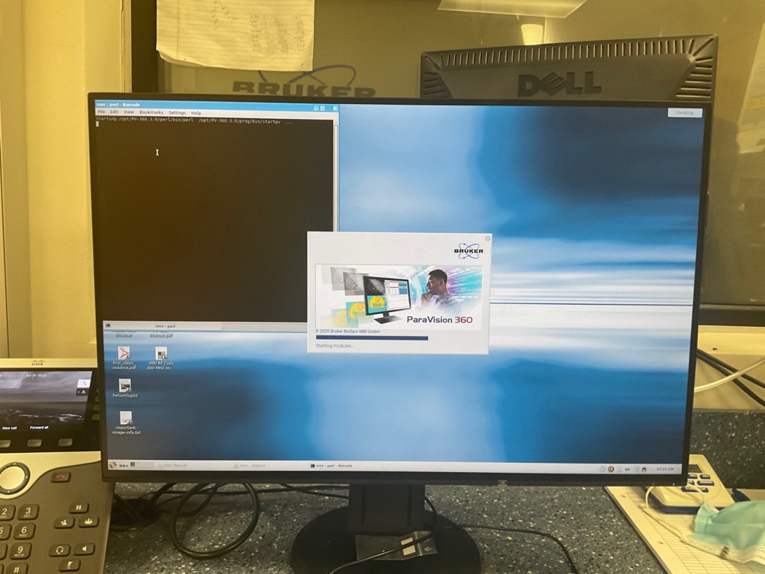

1. When the software is completely loaded, go**:**

* Files >> New >> Study

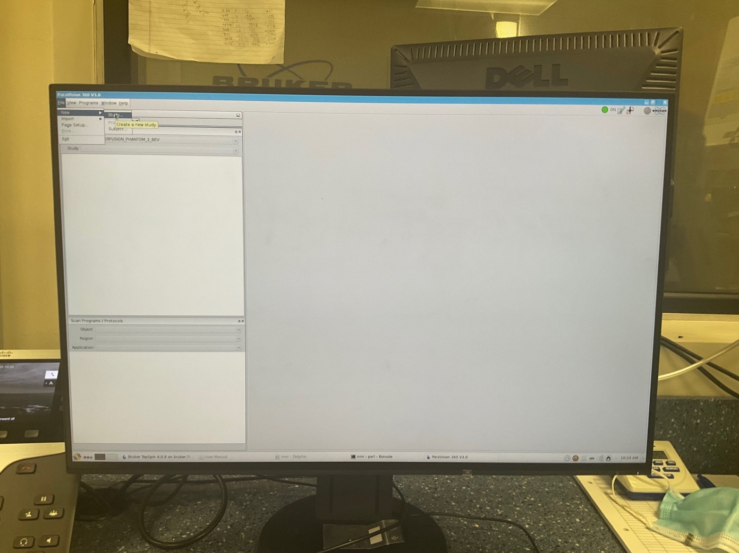

1. Fill the required tabs shown in **bold.**

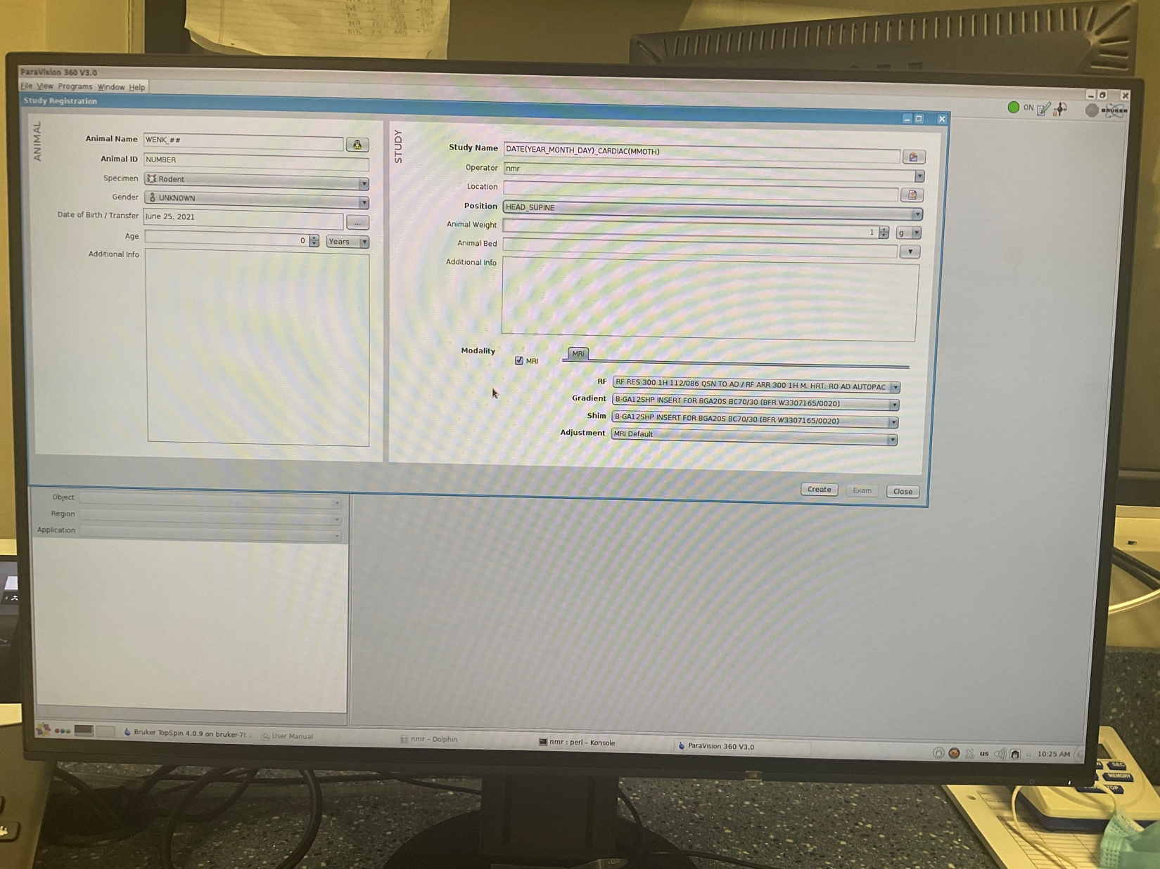

* **Animal Name:** WENK_month_day_year_scan#(eg 01)
* **Animal ID: group_**ID_cage#_physical_markers (e.g. Null_787693_513_G)
* **Study Name:** WENK_HCM_R403Q
* Enter DOB
* **Position:** HEAD_SUPINE

1. Click >> Create >> Exam
2. Go to “Explorer” tab.
3. From “Scan Program / Protocols” tab on the left-hand side, select **user** protocol

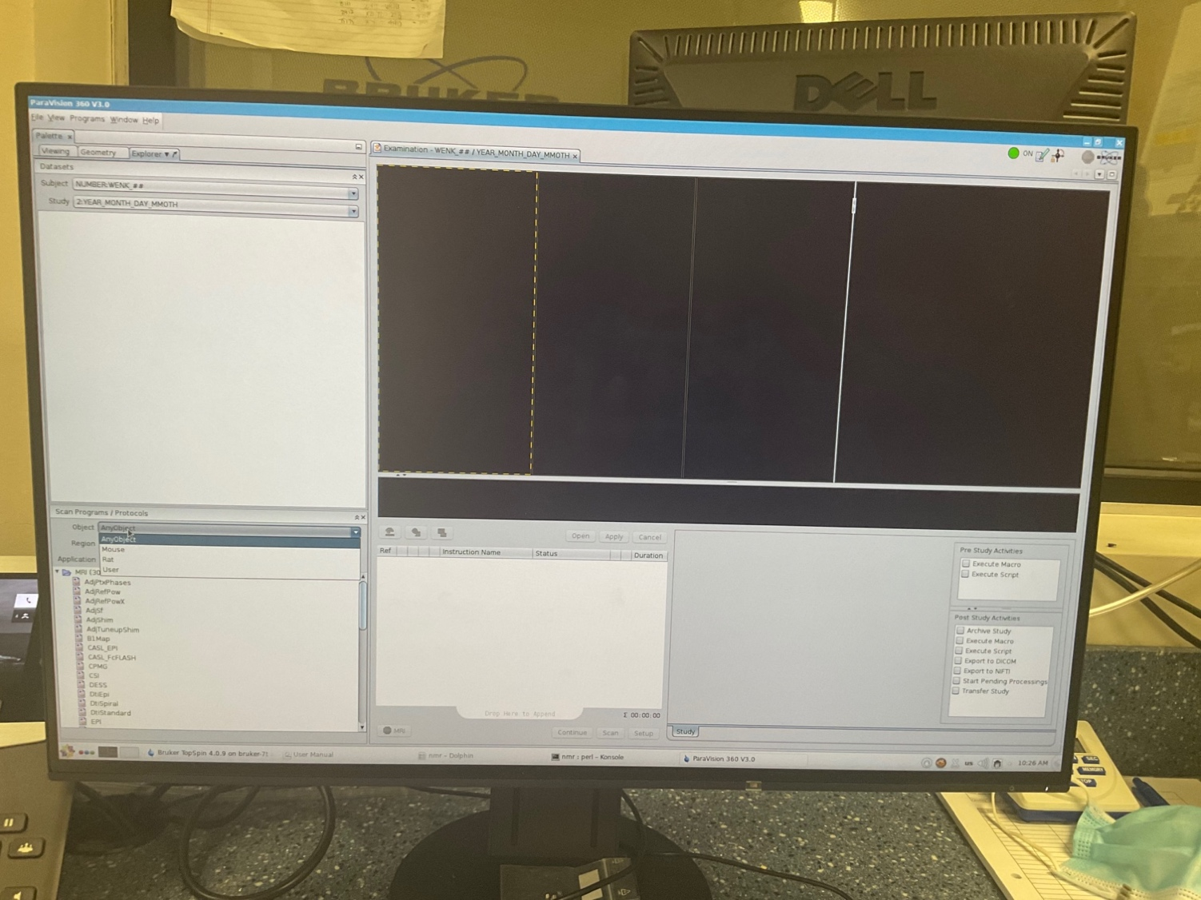

1. From “Scan Program / Protocols” tab on the left-hand side,
2. Select **user** protocol in the “**object**” drop down
3. Select “**Region**”, it should be user-defined protocol for this specific study.
4. Select “Heart” for “Application”.
5. Select the "**localizer**” step from the left_down panel and drag it to middle_down panel.

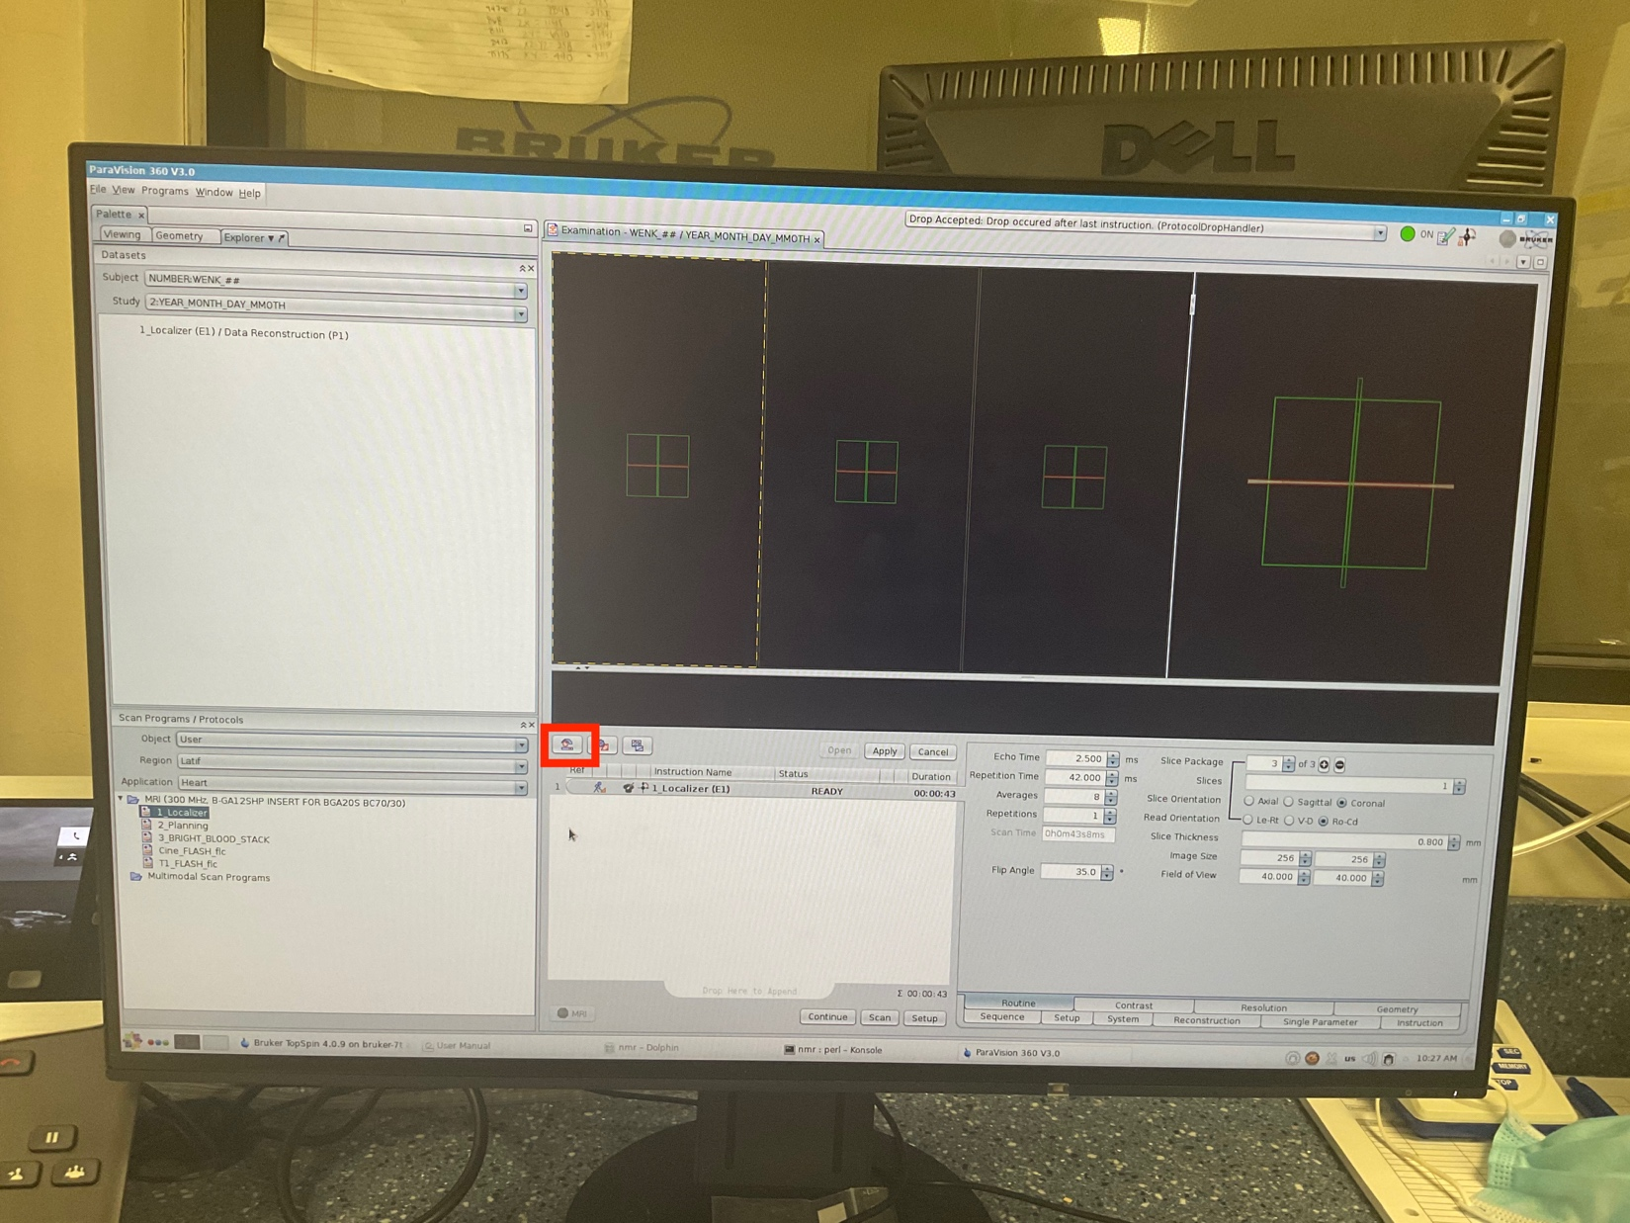

1. Then click on the enclosed icon to open the menu for adjusting the “**wobble**”.

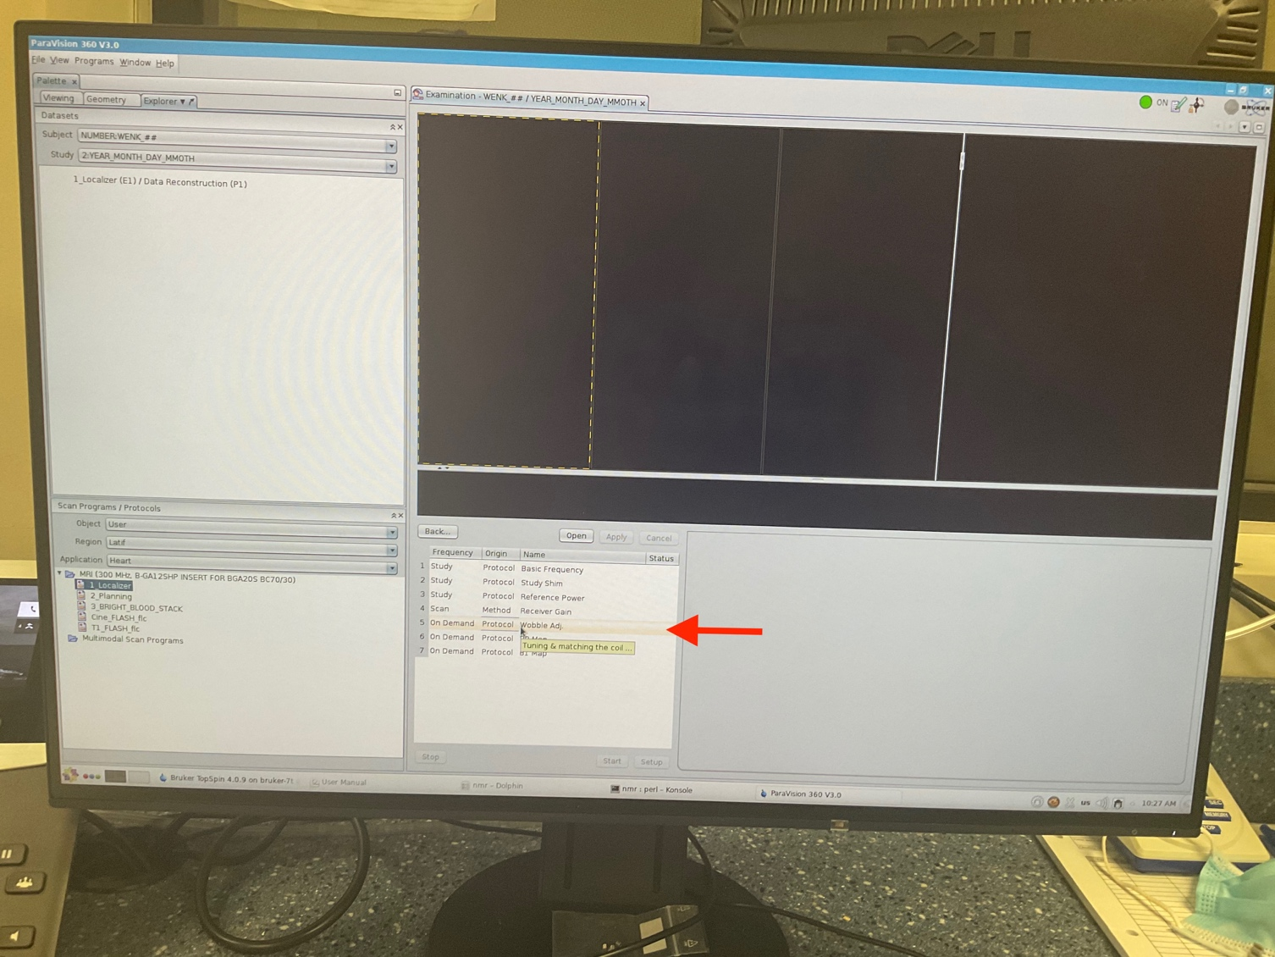

1. Select “Wobble adjustment” shown with the red arrow and “open”.

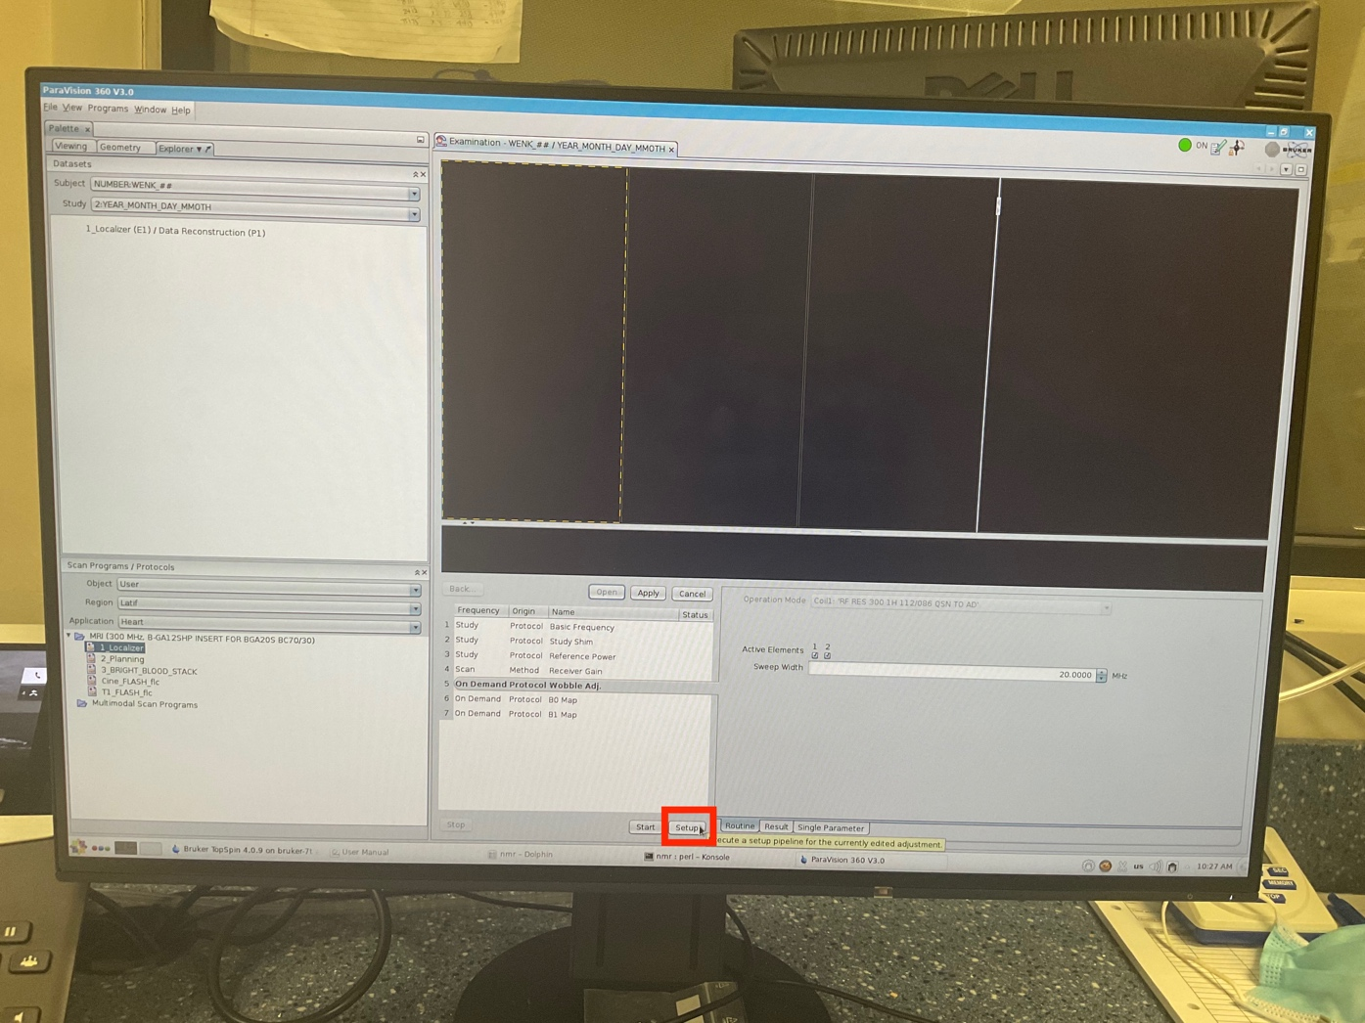

1. Click on “Setup” button to adjust the wobble setting.

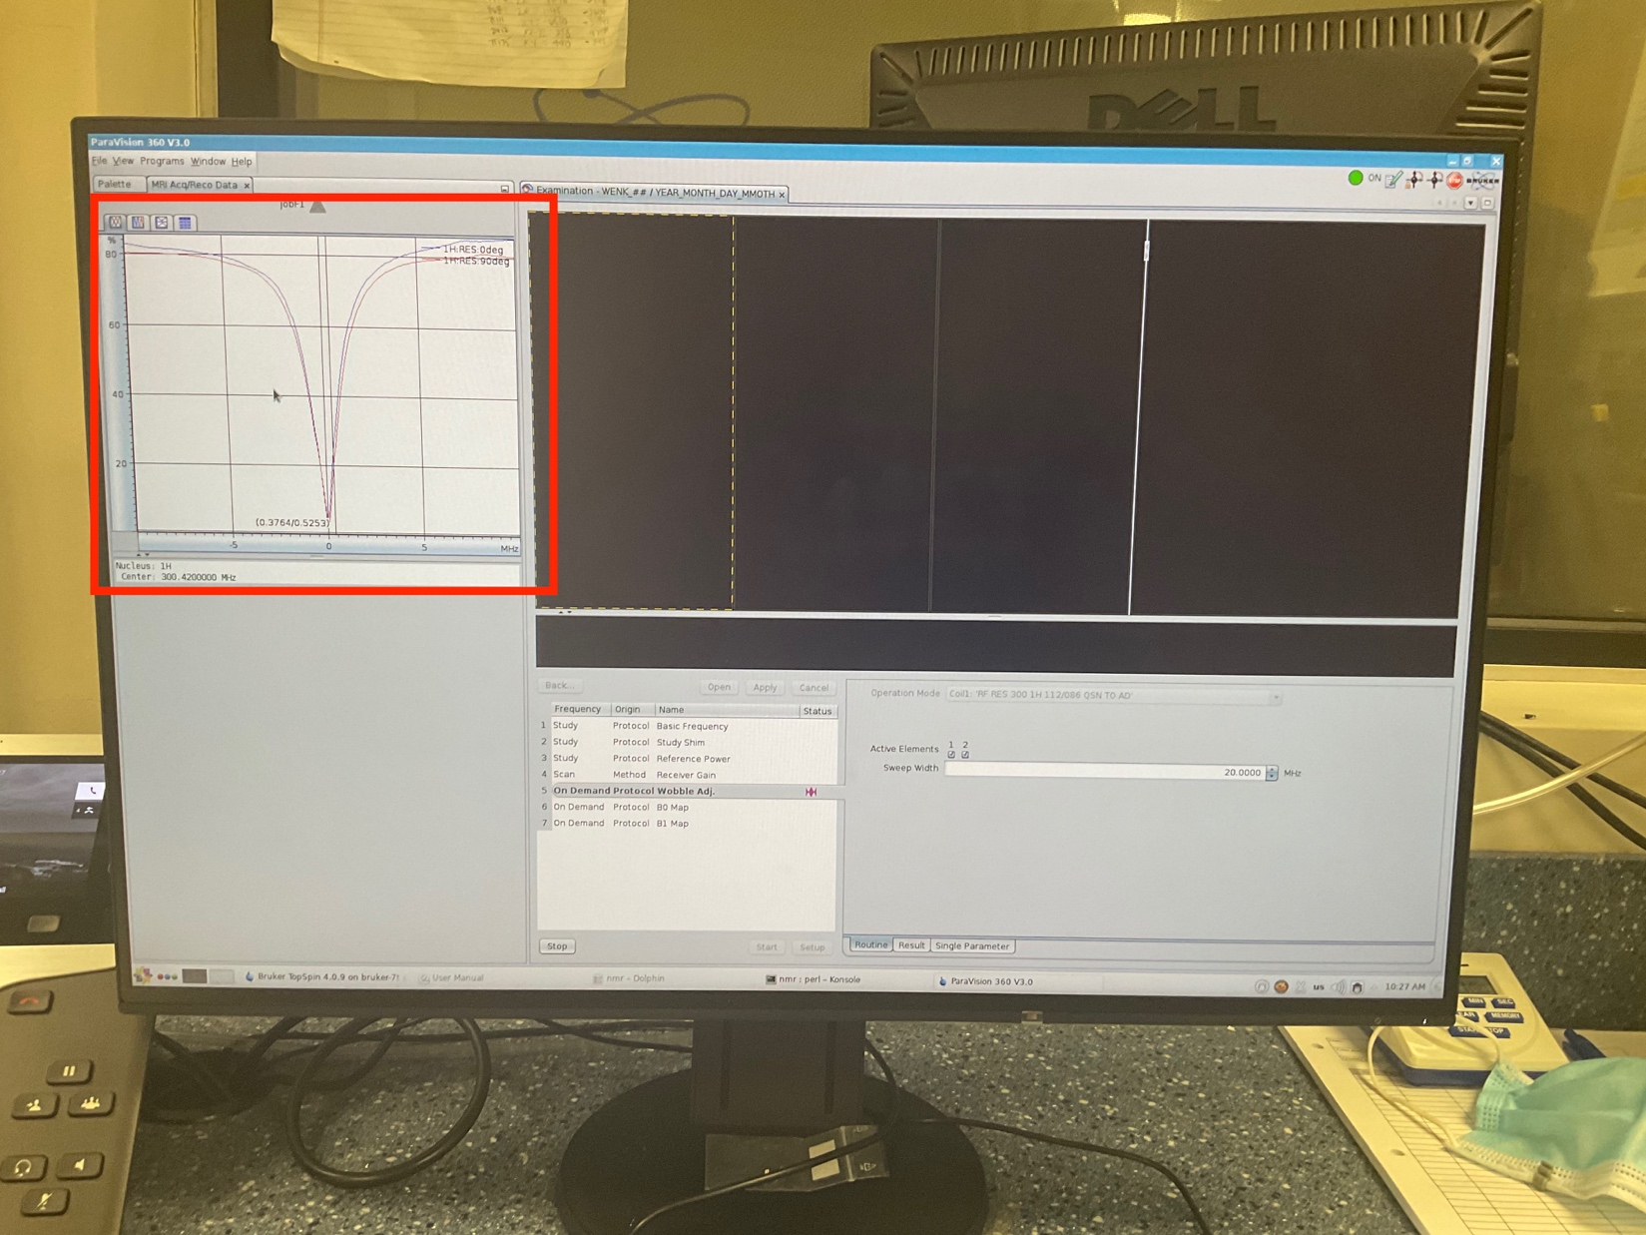

1. Go to the “MRI Acq/Reco Data” tab.
2. Then, the user must go into the scanner room at the behind of the scanner to manually adjust the wobble.
3. The adjustment should be done in a way that:
4. The vertical line would be placed at the center of two diagrams (yellow knobs)
5. The amplitude of diagrams is deep enough to touch the minimum horizontal line/ axis. (green knobs)
6. Then, on the software screen, hit the “stop” button.

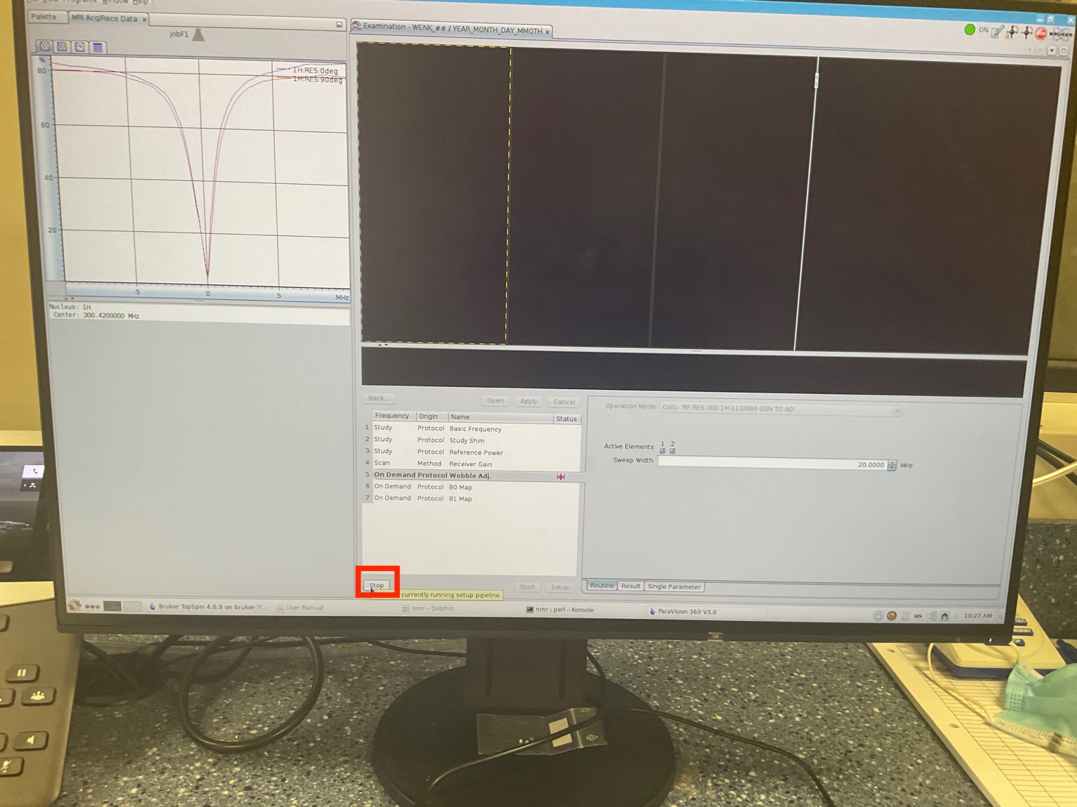

1. Then “Apply” the changes and press “back”.

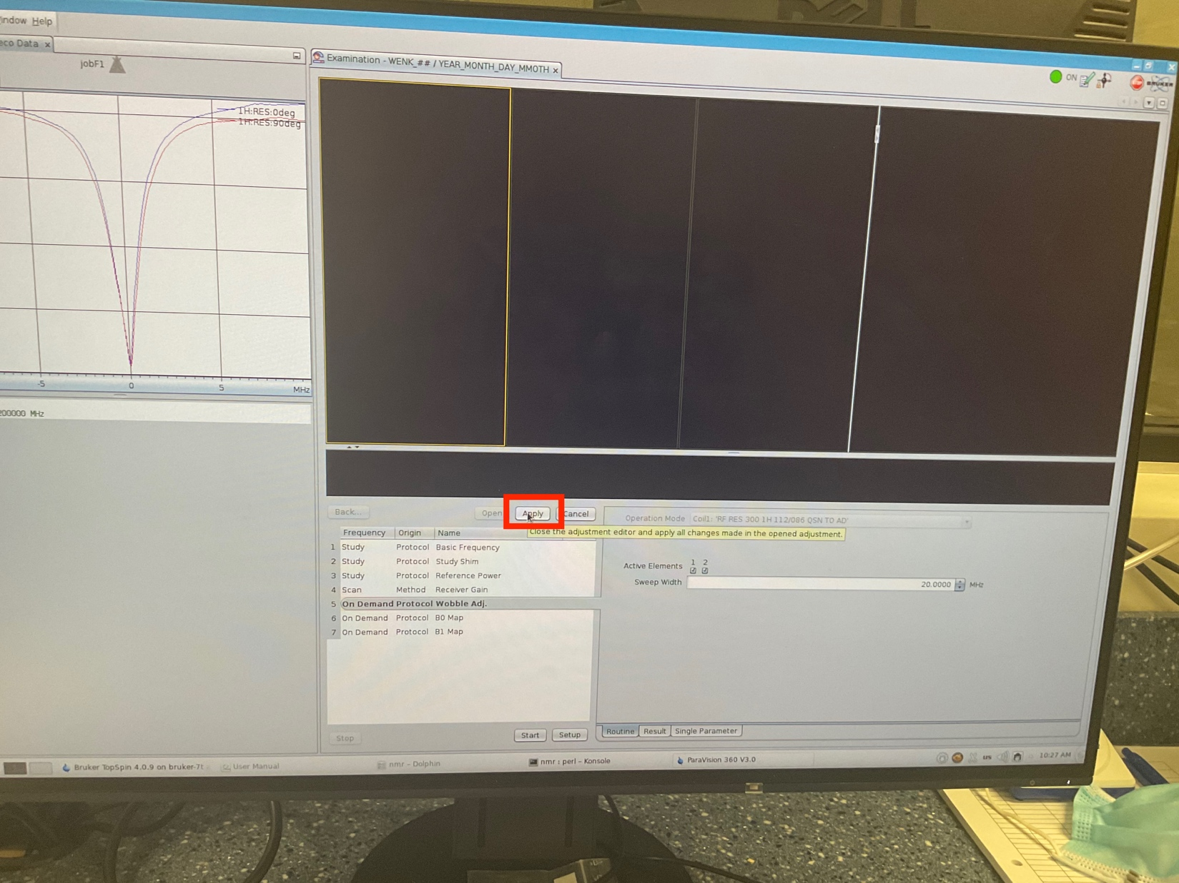

1. Click on “continue” to allow the scanner to start scanning.

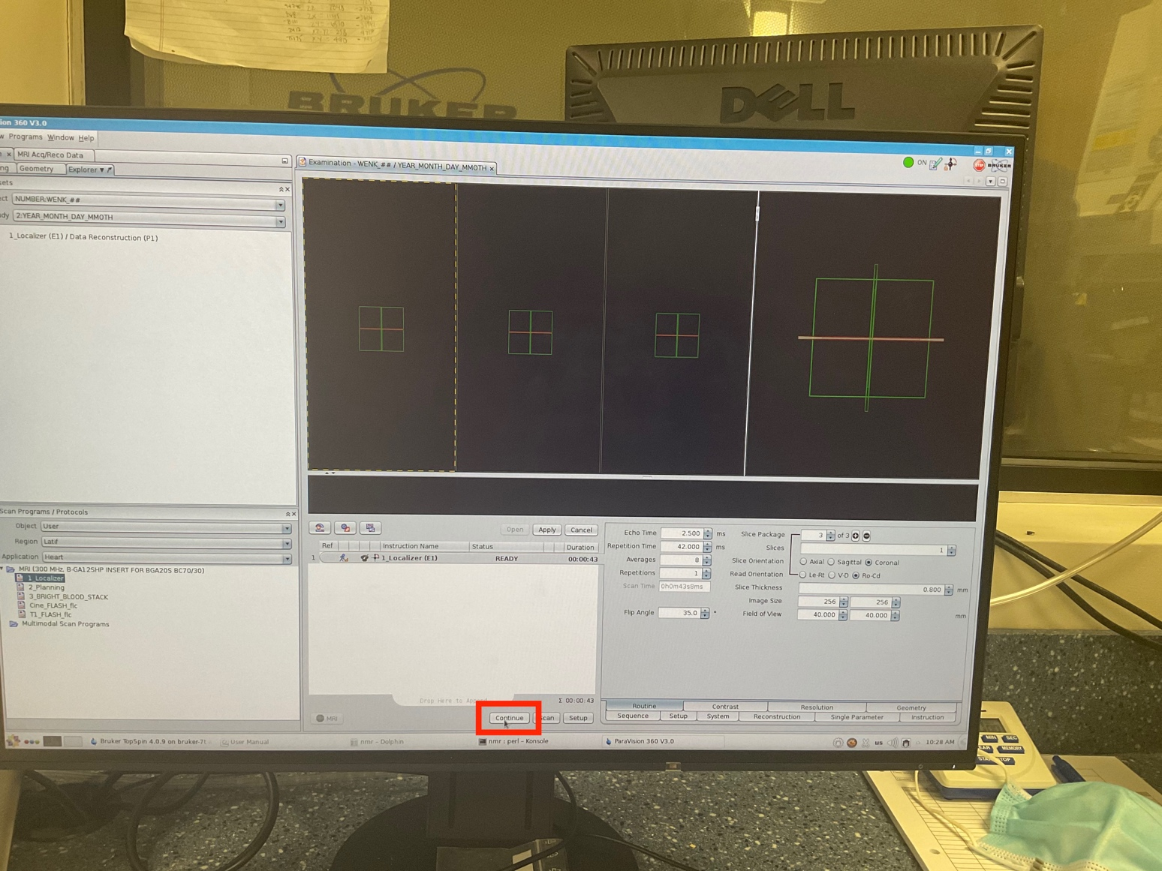

1. Allow the scan to be completed. It usually takes couple minutes.

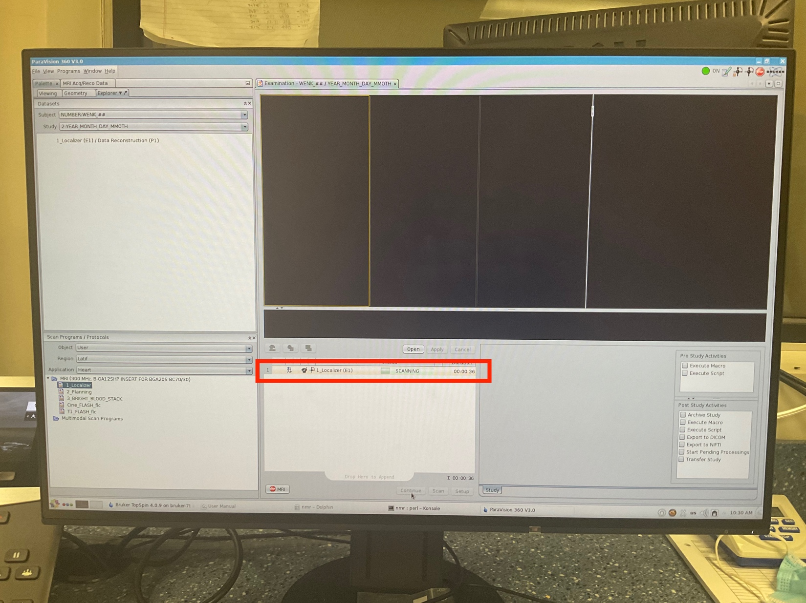

1. **Make sure** the heart is located at the center of the three windows. Otherwise, try to relocate the animal-bed and redo the previous step to make sure you have the heart in the center of windows.

You should get something like below figure.

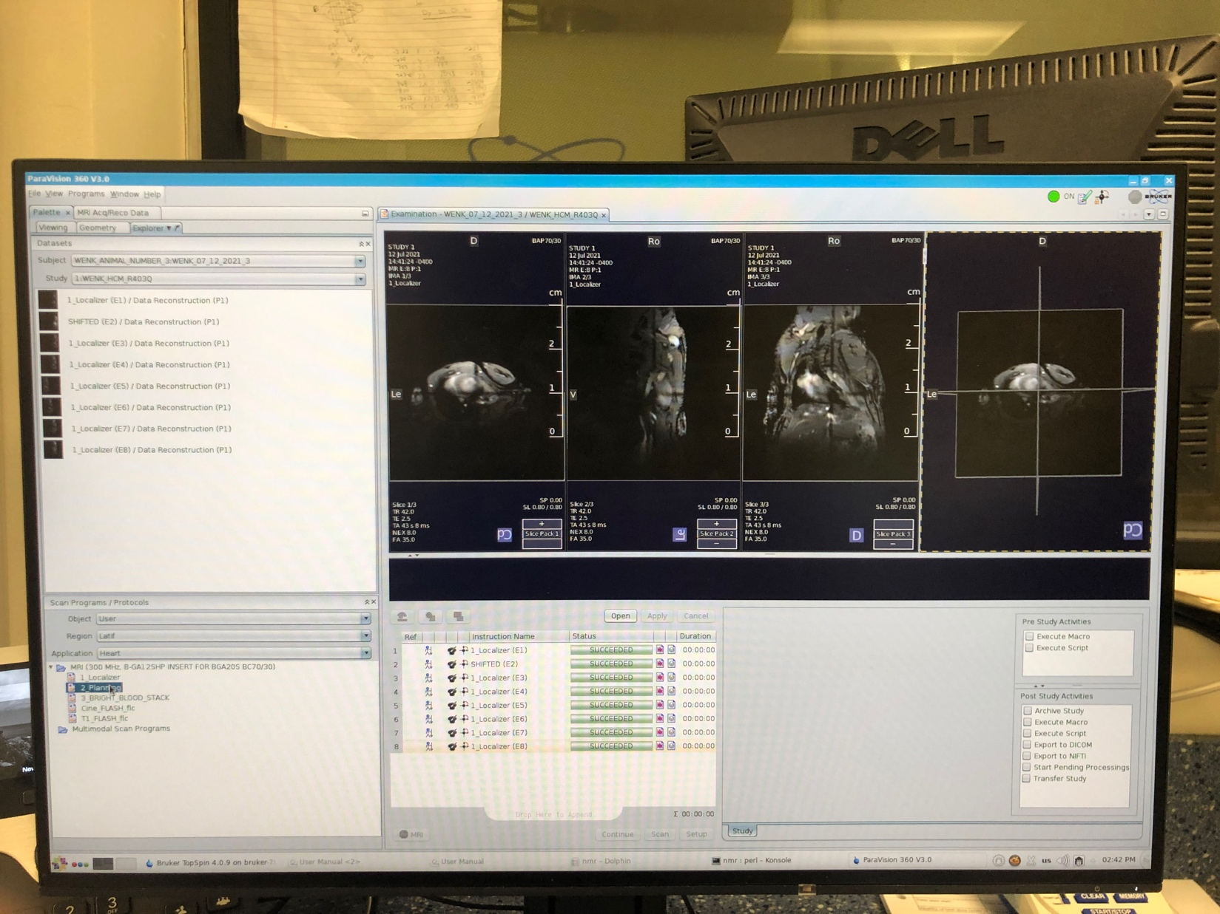

1. When the first step is finished, drag the “**planning**” step to the middle “operating” window.

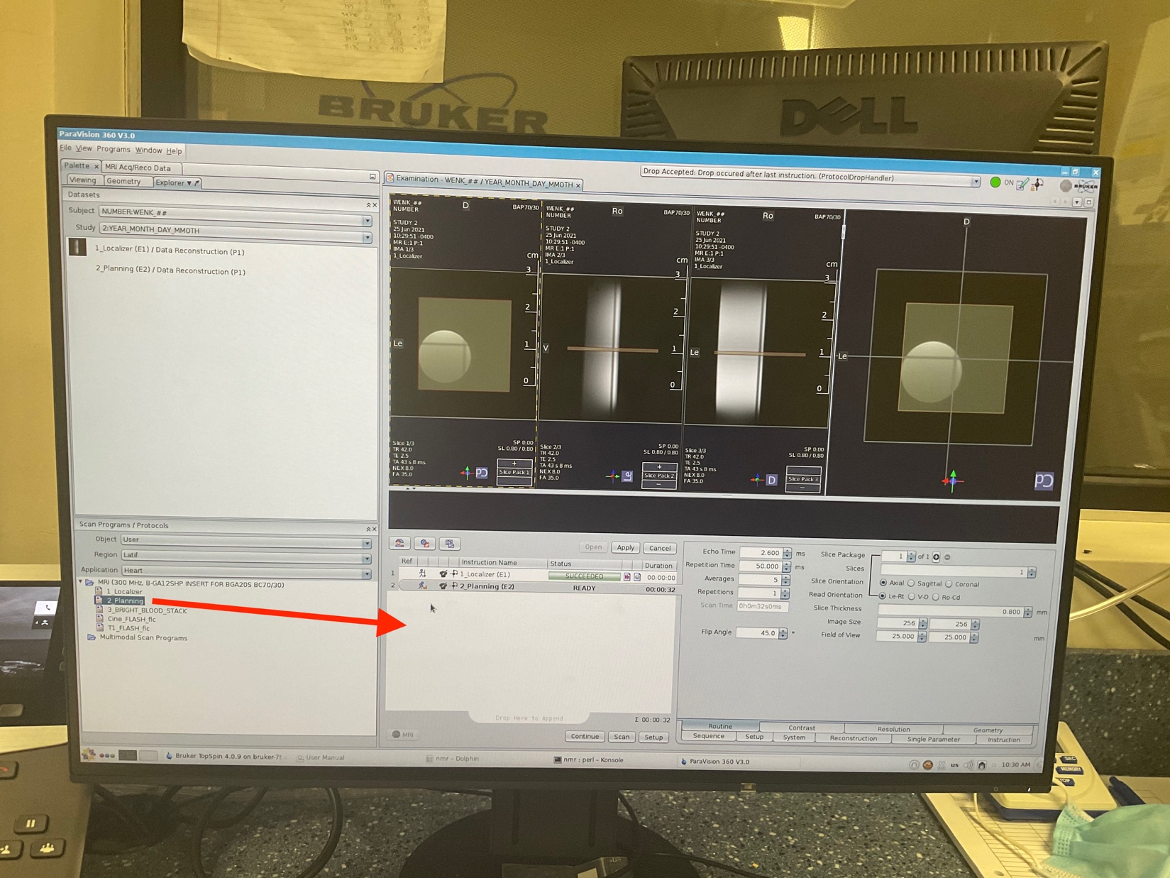

1. Adjust the location of imaging “slice” to be in the center of targeted object/organ (e.g. heart).
2. Start with the longitudinal view (second window)
3. Try to get a short axis image, so you need to rotate the slice to be perpendicular to the long axis view.

Note: to move the plane, move the cursor to the center point and drag the plane.

Note: To rotate the plane: move curser on the plane, once it shows the rotation sign, you can click and hold to rotate the plane.

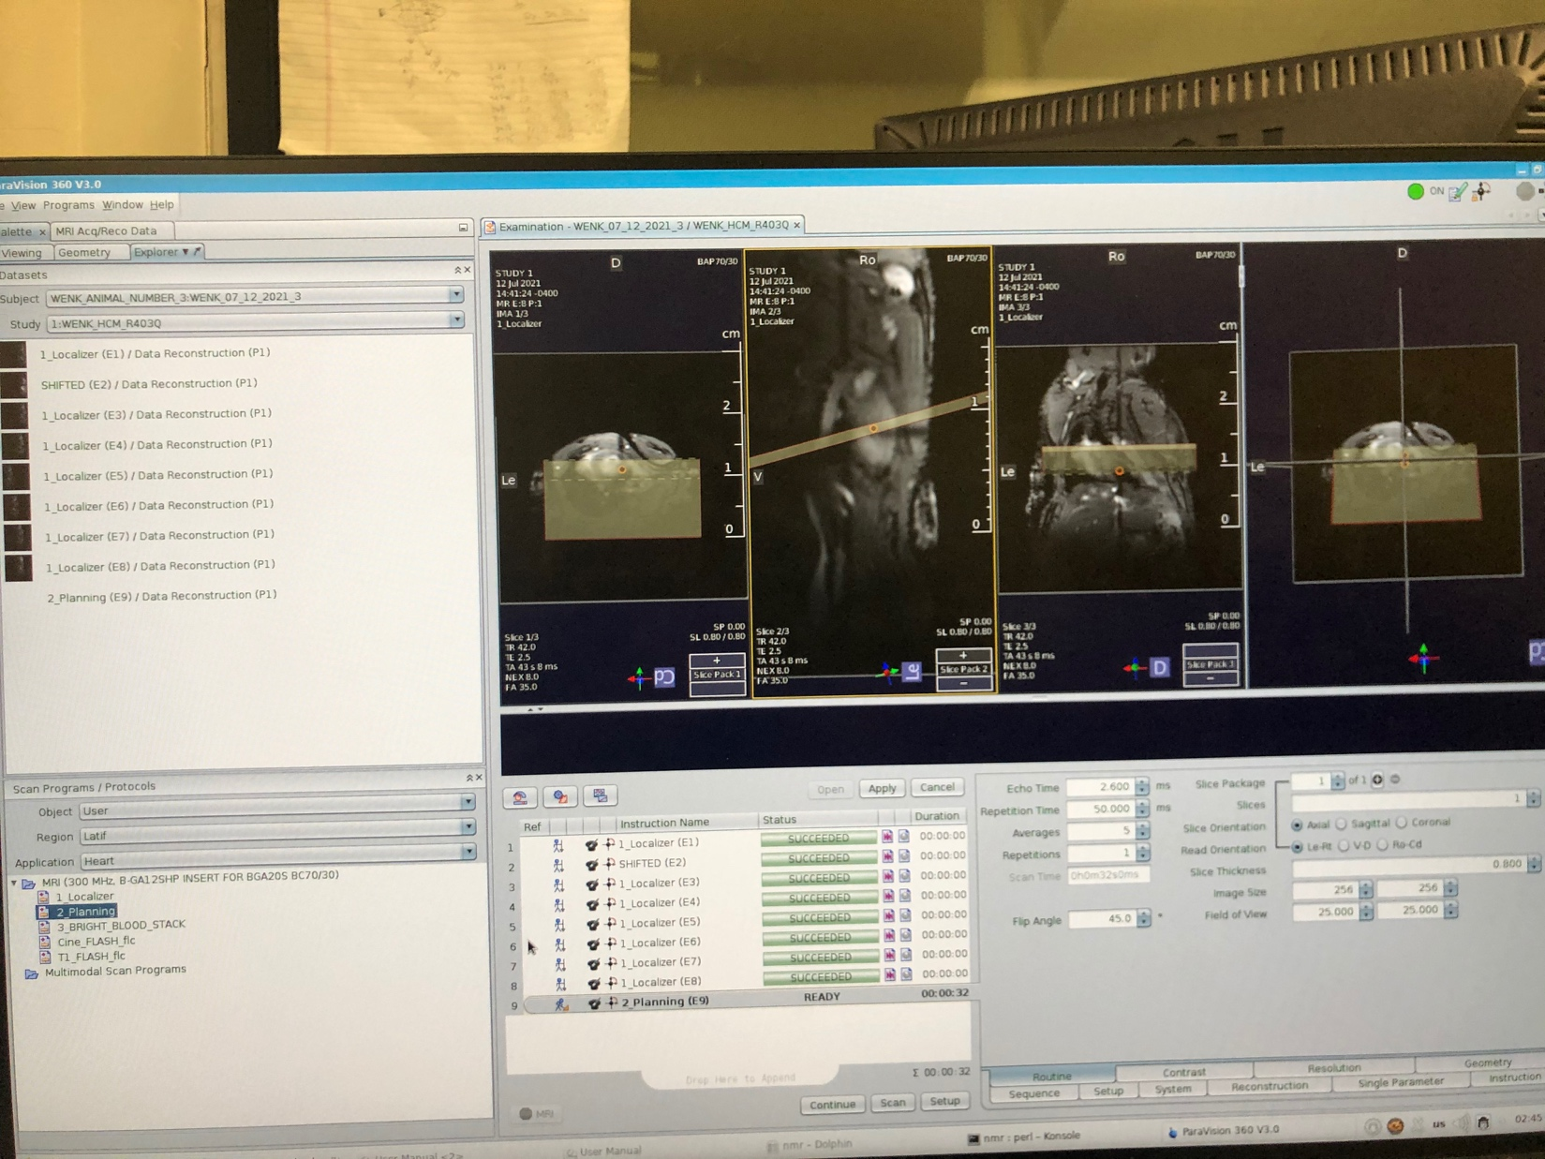

1. Click “continue” to start the scanning.
2. Right click on the previous step and select “duplicate”

* Then “rename” the step to “**POOR_4CH**”

1. Adjust the location of plane to cut through the 4 chamber:

* Activate window that shows the acquired image from the previous step (Planning).
* Go to “**Geometry**” tab, under “Align” panel select the red arrow button to make the slice perpendicular in the “**planning**” image.
* Manually rotate the slice to get a 4_chamber view.

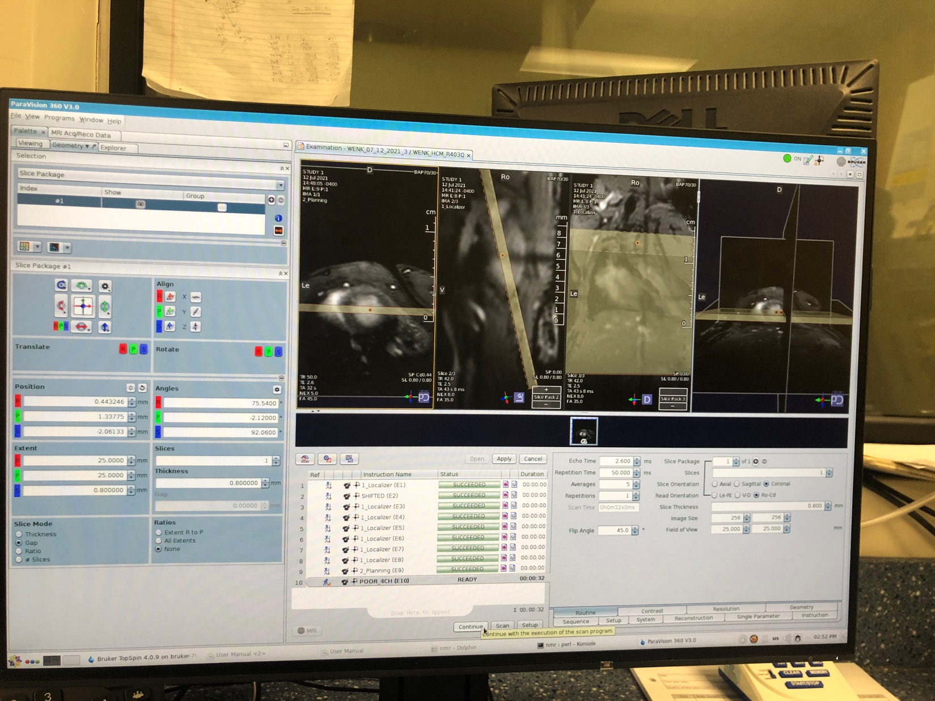

1. Press continue to scan.
2. Duplicate the “**POOR_4CH**” and rename it to “**POOR_2CH**”.
3. Adjust the location of the plane to cut through the two-chamber view and then press continue.

Note: It is recommended to adjust the slice on the 4_chamber view image. To do that:

I- Make the slice on the 4_chamber window to be perpendicular.

II- Then place the center of the slice on the apex of the heart and adjust it to cut through the 2_chamber view.

III- Then move back the center of the slice to the center of the LV (**no more on apex**)

**Note**- Don’t trust the “short axis” views because they may not be appropriately orthogonal. If it was needed adjust the slice on the “short axis” image as well.

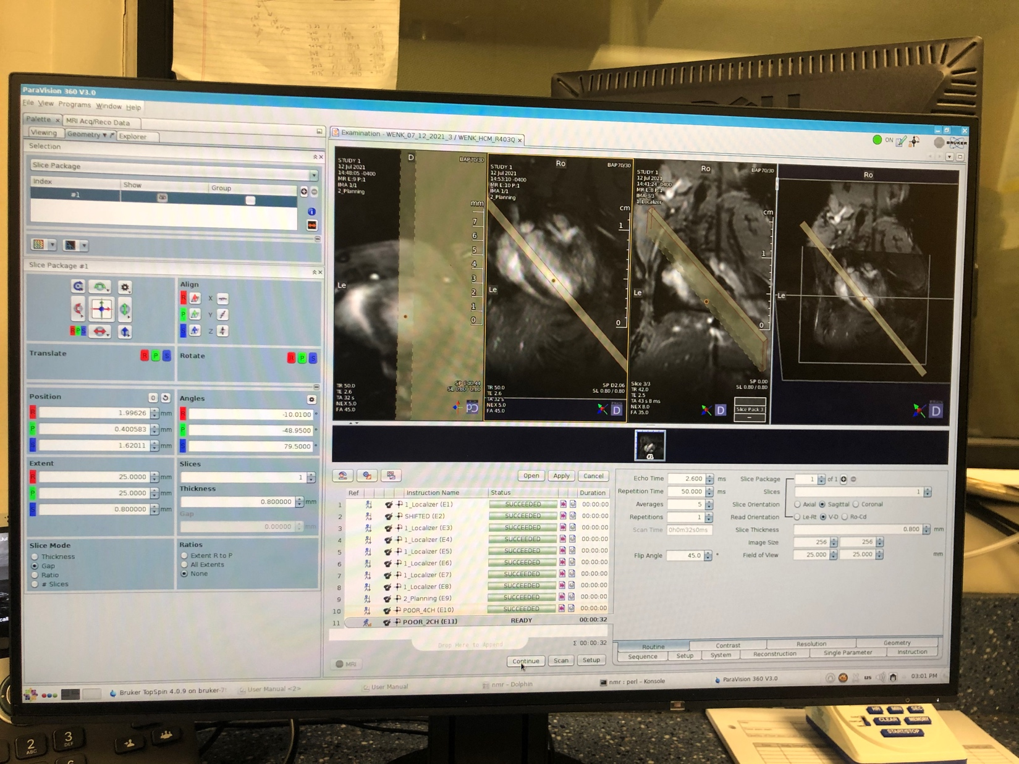

1. “Continue” to scan.
2. Duplicate the “**POOR_2CH**” and rename it to “**MID_SA**”.
3. On either “**POOR_4CH**” or “**POOR_2CH**” windows, move the location of plane to get the short axis view from the basal location. **Tip from Dave**: Image a line tangent to the mid septum. The short axis slice should be perpendicular to this.
4. “Continue” to start the scan.
5. Open “**CINE_IG_UTE**” step.
   1. First, copy the slice orientation from the MID_SA slice
   2. Position the slice to obtain a basal short axis slice on the **POOR_4CH**.
   3. Go to Navigator tab in the slice settings,
      1. Click the button for parallel. This gets the navigator slice parallel to the new slice orientation.
      2. Then click the radio button for arbitrary.
   4. Go to the geometry tab at top left,
      1. switch the dropdown from trajectory to navigator.
      2. Select #1. This allows you to move the navigator.
   5. Move the navigator to be ½ slice thickness above the top slice that will be acquired.
   6. Open the “wobble” icon, the first from the left, to adjust the “basic_frequency”

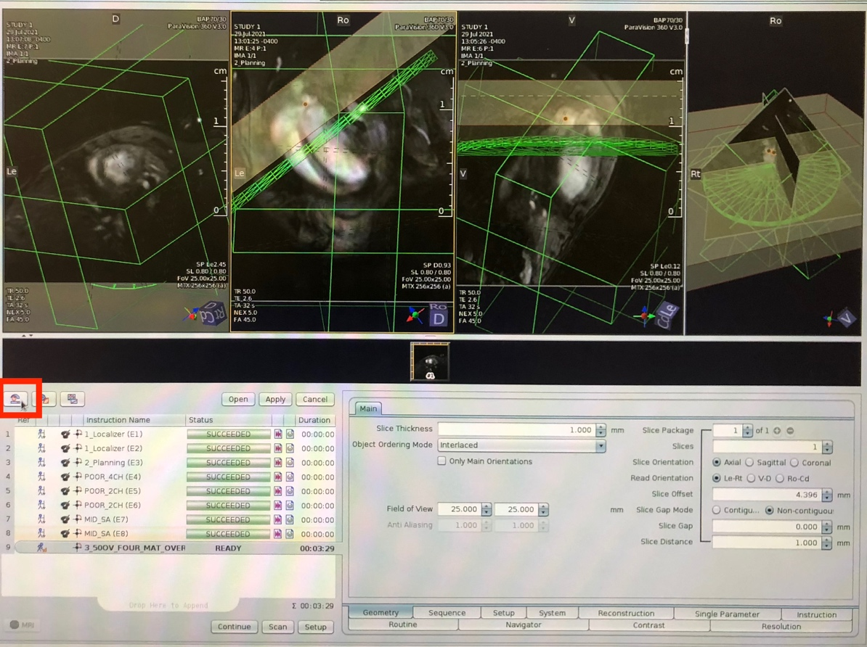

* 1. Worth going through “basic frequency”,
     1. Select “basic frequency”
     2. Open and then Setup
     3. Once finished, click “Apply”
     4. Repeat the two previous step for “study_shim” and “reference_power”
     5. and then repeat the basic frequency step again

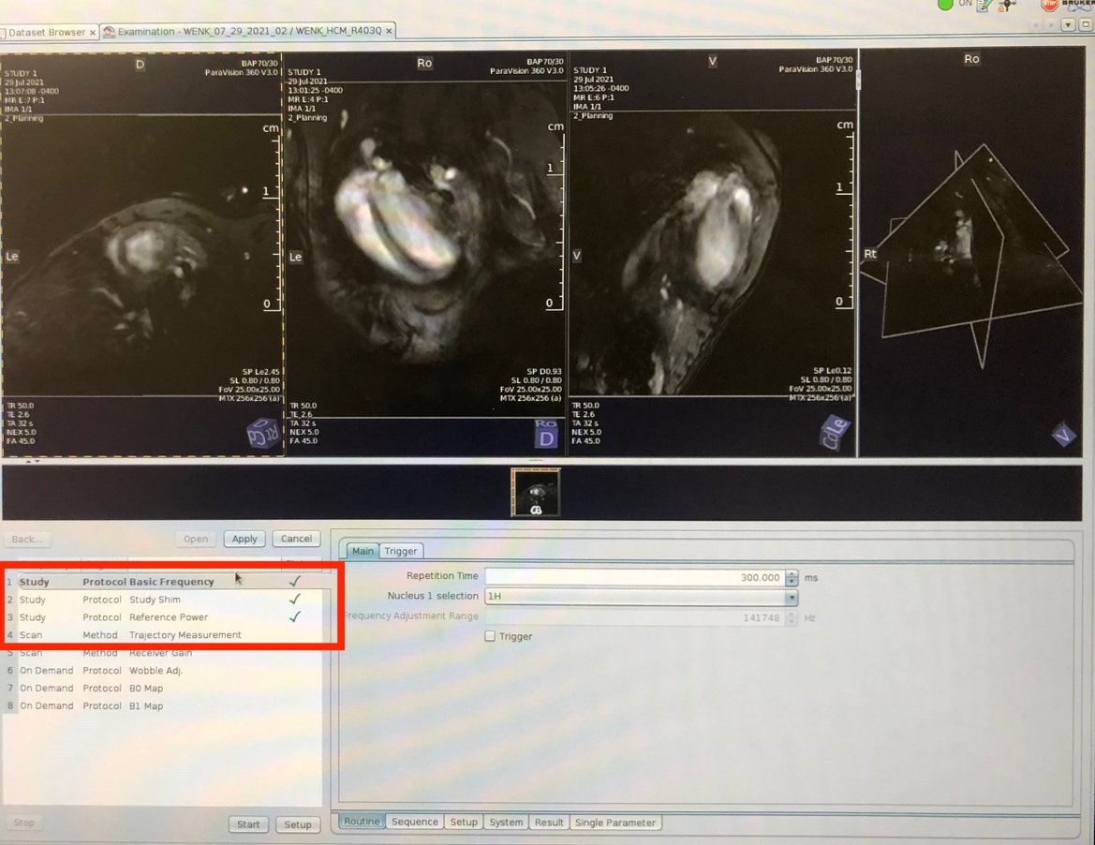

* 1. Hit continue

1. To build the stack, duplicate the previous step.
   1. Rename to SA_2
   2. In the “geometry” settings for the slice, increment the slice offset to move the slice down by one slice thickness.
   3. Repeat until the full stack is obtained.
2. Long Axis Slices:
   1. Once the SA_3 (mid SA) is finished, load SA_3 to the window 1, go to ED frame
   2. Duplicate the last step, and rename to LA_2CH
   3. The slice can be translated perpendicular to the slice plane
   4. Make the slice perpendicular to the SA_3 image
   5. Orient the slice to be centered in the LV, and to obtain a 2 chamber view such that the slice cut through the insertion points
   6. Hit continue
3. Duplicate the previous step.
   1. Rename to LA_PLUS_60
   2. Rotate the plane +60 degrees from the 2 chamber slice
   3. Hit continue
4. Duplicate the previous step
   1. Rename to LA_MINUS_60
   2. Rotate -60 degrees from the 2 chamber slice
   3. Hit continue

**How to export data:**

1. Close the study tab
2. Select the scan data: Window -> Dataset browser
3. Click Export to dicom: Click OK
4. Then go to the folder explorer on the operating system
5. Go to 1.8 TB drive
6. Go to PV-360.3.0/data/nmr
7. Then you can sort by date or name
8. Select the main folder and copy into your hard drive.

* To access the “view” tab, the user can do “right_click” on a completed step in the left-top window and select the “view” tab.

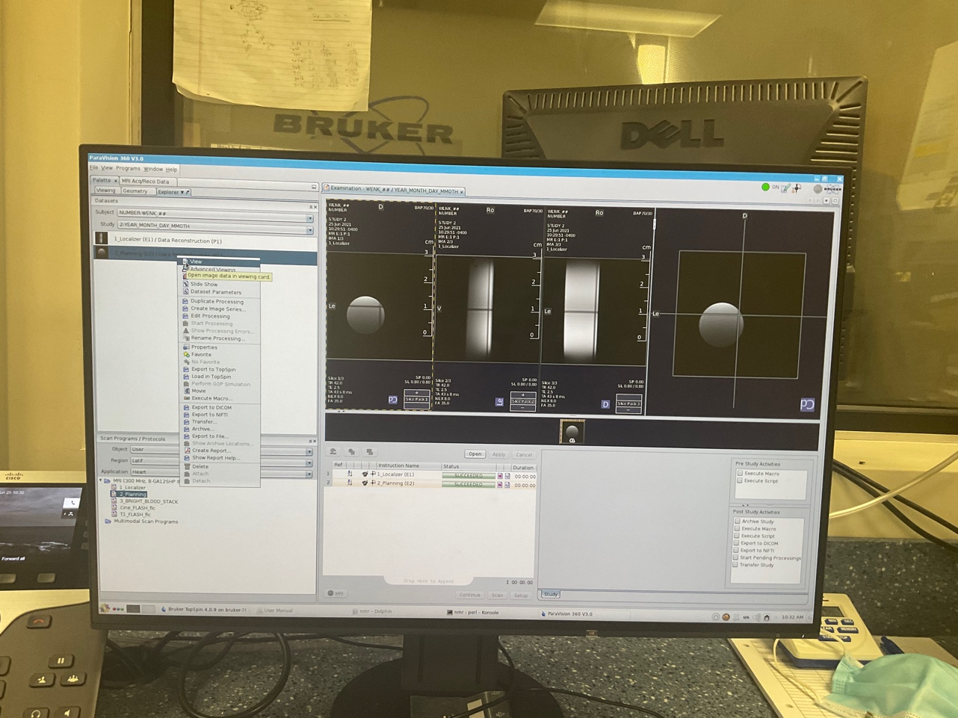

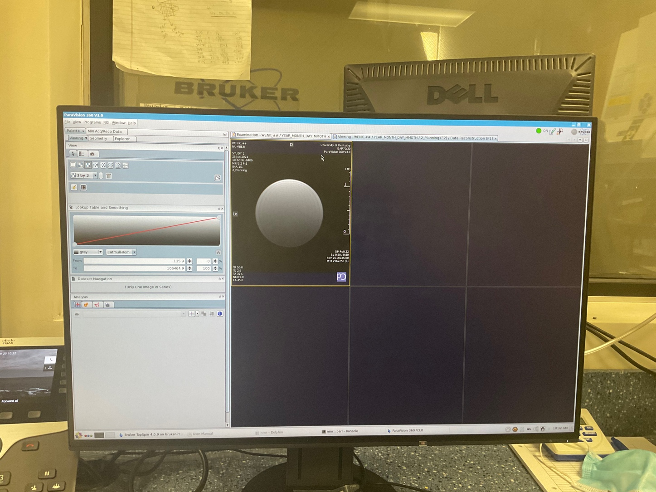

* To access scanned projects and export data:

Window >> “Dataset Browser”

